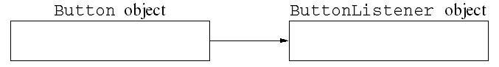
import java.awt.*;
import java.awt.event.*;

public class ButtonTest {
public static void main(String[] args) {
Frame f = new ButtonTestFrame("Button Test");
f.setSize(150, 100);
f.setVisible(true);

}
}

class ButtonTestFrame extends Frame {
public ButtonTestFrame(String title) {
super(title);
setLayout(new FlowLayout());
Button b = new Button("Close window");
add(b);
b.addActionListener(new ButtonListener());

addWindowListener(new WindowCloser());
}
}

class ButtonListener implements ActionListener {
public void actionPerformed(ActionEvent evt) {
System.exit(0);
}
}

class WindowCloser extends WindowAdapter {
public void windowClosing(WindowEvent evt) {
System.exit(0);
}
}



